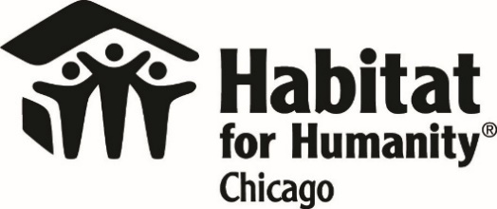

Application Form
Neighbors United Block Improvements Initiative

Please return this form to Habitat Chicago before the first day of the project period (at least three weeks prior, preferred). Submit your application via: email: neighborhoods@habitatchicago.org or mail/in person: Habitat for Humanity Chicago, 1100 W Cermak Rd., Ste. 404, Chicago, IL 60608. Questions: 312-563-0296.
BLOCK
NEIGHBORHOOD |  | West Pullman Greater Grand Crossing
PROJECT PERIOD |  | Spring (Apr-May) Summer (Jun-Aug) Fall (Sep-Nov)
YOUR NAME
YOUR ADDRESS
YOUR EMAIL
YOUR PHONE

- Please describe your Block Improvement project idea.

- Why is this project important to you and your neighbors?

- How many residents on the block have committed to participating in your project? How many do you expect to participate if selected?

- What will you do to ensure your neighbors will participate?

- When will the project take place?

- What do you think the project will cost?

- Is there anything else we should know?

Agreements:
- If selected, we will work with Habitat Chicago to submit material orders in a timely manner so that our project may be completed on time.
- If selected, we agree to place temporary yard signs on the corners of our block for at least four weeks after the project completion indicating we participated in the Neighbors United Initiative.
- If selected, we agree to submit a simple final project report within one week of the completion of the project.

Signature: ______________________________________ Date: _________

