You Got Flocked!
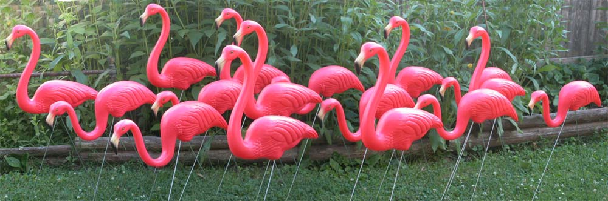

Surprise! You have been flocked by your <<Insert Team Name>> friends as a fundraiser for Habitat for Humanity Chicago’s Women Build! These flamingos will nest at your desk until:

$10 donation – relocate the flock to a friend of your choice
$25 donation – keep the flock happy at your desk for half the day
$50 donation – spend the whole day with your flamingo friends!

To donate, go to <<insert link to team fundraising page here>>.
If you are unable to donate at this time, or have already donated (Thank You!), contact our team of flocking experts (Insert names and email addresses here) to remove the birds at no cost.

A HUGE thank you to every one for your support of this great cause!
Sincerely, the Women Build team: <<Insert names of your team members here>>

